

**About Guru Alexa Skill - How to setup and use**

**If you own a echo device (if you don’t please scroll down)**

Find the skill at this link <https://www.amazon.com/gp/aw/d/B07D3JHB48/ref=mp_s_a_1_1?ie=UTF8&qid=1526748232&sr=1-1&pi=AC_SX236_SY340_FMwebp_QL65&keywords=About+guru&dpPl=1&dpID=710EPpqSrFL&ref=plSrch>

1. Go to your Alexa app -> Skills -> Search -> About Guru (you will see the skill with the above icon)
2. Click on the skills and select Enable skill.
3. That’s it. Now About guru skill is enabled on all you echo devices.
4. Use the alexa app to see the contents that alexa sends to you if you have an echo dot and an echo plus.

**If you don’t own a echo device**

**Do not worry you can still use the skill through alexa on your mobile.**

1. Download the amazon alexa app on your mobile phone.
2. Login to your amazon account. (hoping everyone has one)
3. Go to your Alexa app -> Skills -> Search -> About Guru (you will see the skill with the above icon)
4. Click on the skills and select Enable skill.

**Android (After step 4)**

* If you have an android phone you are one of the lucky ones.
* You just have to click on the alexa icon.

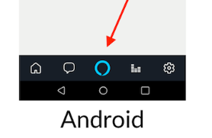

* Tap the button and speak to alexa.

**IOS (After step 4)**

This is where it gets a little complicated. As you can see below there is no alexa icon



Amazon has not yet rolled this feature up for IOS but it is on the way. Meanwhile here is the workaround.

* Once you have enabled the skill on your app in ios. Download the amazon app with below logo.



* Open the amazon app not the amazon alexa app. Login with same credentials that you used for amazon alexa app. Now tap on the alexa icon. just below the shopping cart in the upper right corner.

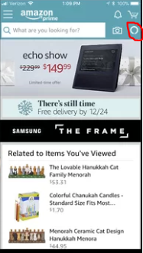

* You will see a blue line at the bottom like this and you can use alexa.
* Use the alexa app to see the contents that alexa sends to you.

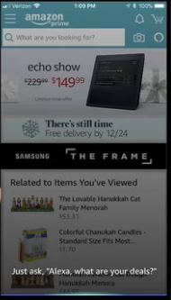

**What to ask Alexa:**

**Description:**

Everything should be in the description of the app. But let me repeat it here.

This skill allows you to ask Guru questions on his likes, job, education, work experience, his technical skills, projects, publications, certifications, interests or you could ask to contact him and get his email address.

If you think you know him well enough then take the quiz, How well do you know guru! a simple game of quiz about guru and see how well you score.

**Phrases:**

**A little background -** once you enable a skill there will be an invocation name for that skill (**guru’s diary**) for my skill. So you have to use the invocation name to use my skill as described below. If the session is open (the blue ring on echo devices and blue line in your app glows) you can just ask alexa about me without the invocation name.

Eg: what is his favorite movie?

But if the session ends then you should use the invocation name (**guru’s diary**) to ask about me

Eg: ask guru’s diary, what is his favorite color ?

**Using the skill with phrases:**

say "open guru's diary" then you can ask things like "technical skills", "favorite color" etc. (until session is open meaning the blue ring on echo devices and blue line in your app glows)

**Or use phrases like**

* "ask guru's diary about his technical skills"
* "ask guru's diary for his contact"
* "ask guru's diary about his publications"
* "ask guru's diary what is his favorite song"